Mood-board[1]

Tags: speaking, warm-up,

Type: solo activity

Time: 5 minutes

## **Why are we doing this?**

A journey of a thousand miles starts with one small step. This exercise is that step. Having the students produce one syllable of the target language while doing roll-call will make them more likely to keep producing said language. It is also an effective way to feel out the status of the class.

## **What materials/set-up do I need to prepare?**

There are plenty of mood-boards available online. Find one that can be connected to the lesson or just something out of the current pop culture and stick it on the board as you do the roll-call.

## **How do we do this?**

Find a mood-board online. Stick it on the board. Have the students say the number they relate to as you call them up during roll-call.

**For example:**



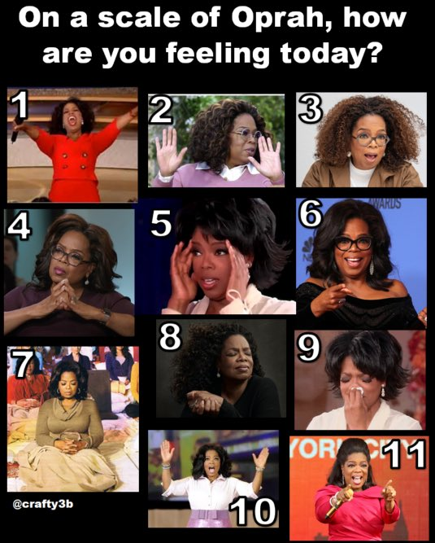  


















1. **Source:** My friend and fellow teacher Guðný Ósk Laxdal told me about this method. It always gets her students’ attention